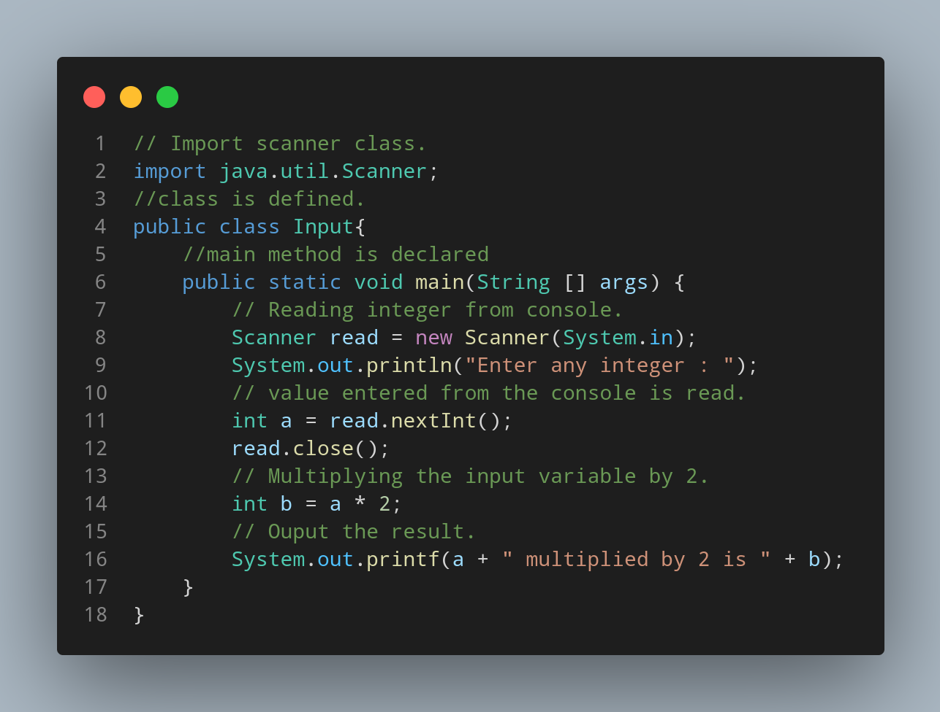

#Doc

java.util.Scanner class is imported.
Input is declared as class.
Main method is declared.
Code to read the data entered from console is written.
Code to print the required output is written.
Code to read and assign a variable to the entered data is written.
Variable b of integer data type is declared.
Code to output the result is written.

